**Name – Parag Gattani**

Program No. – 07

Program Title – Distance Measurement using ultrasonic sensor

**AIM**

Design a system to measure the distance between objects.

**HARDWARES REQUIRED**

* Arduino Board
* Ultrasonic sensor HC-SR04

**CIRCUIT DIAGRAM**

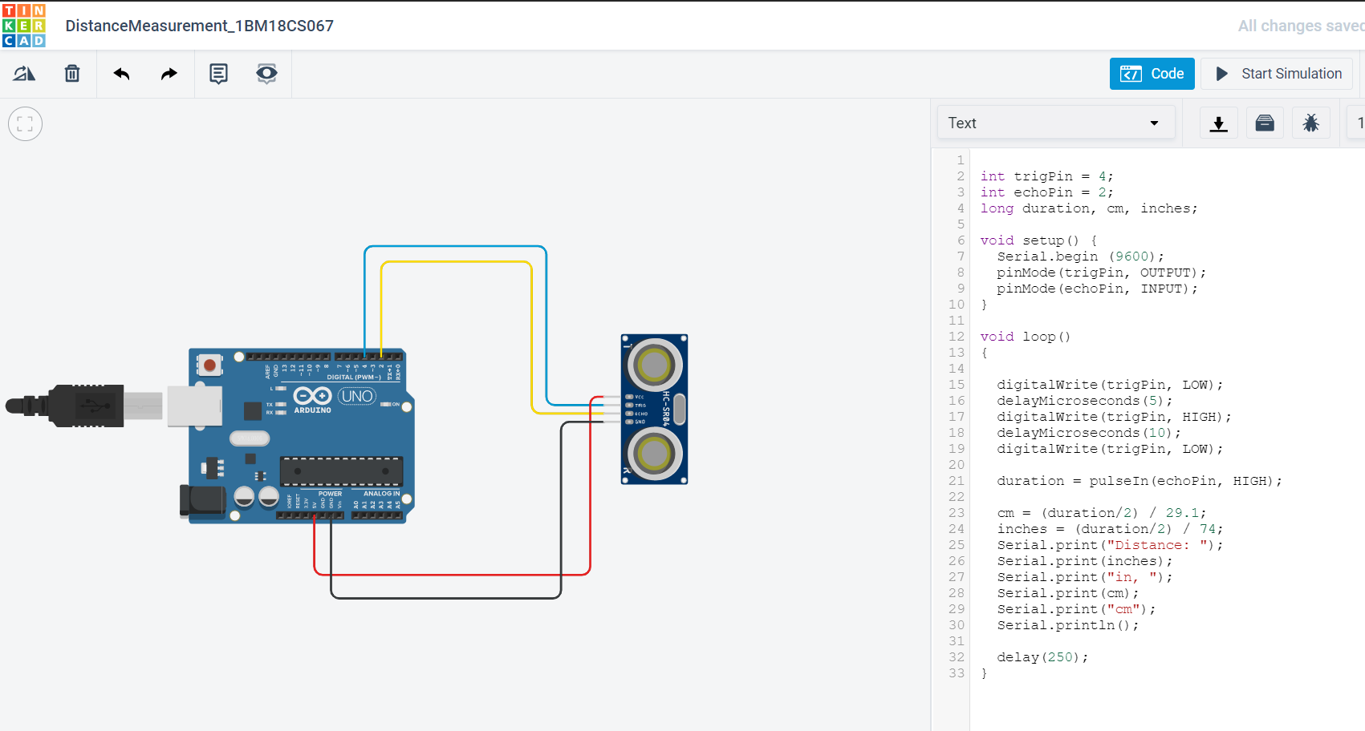

**WRITE-UP**

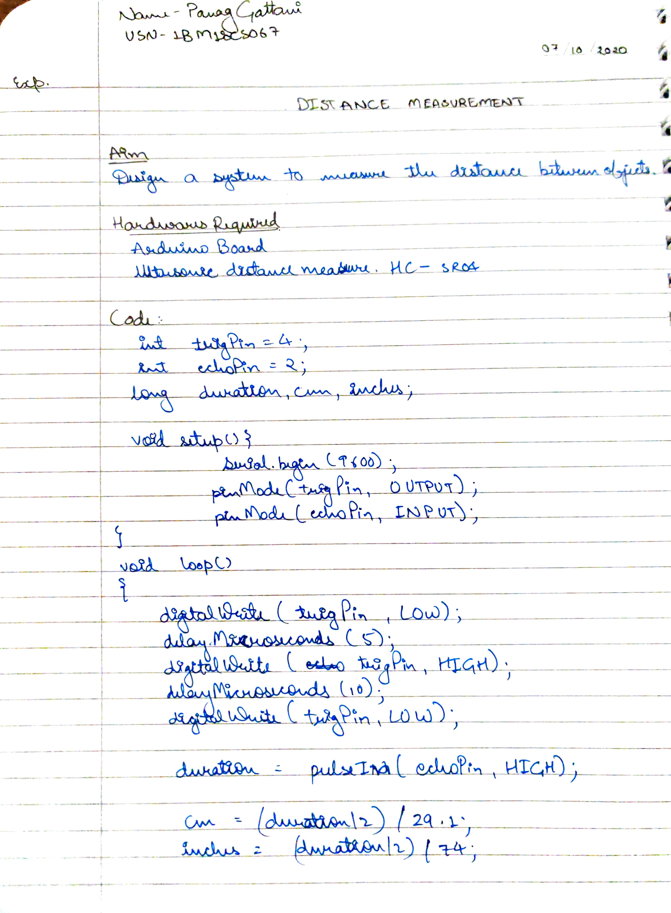

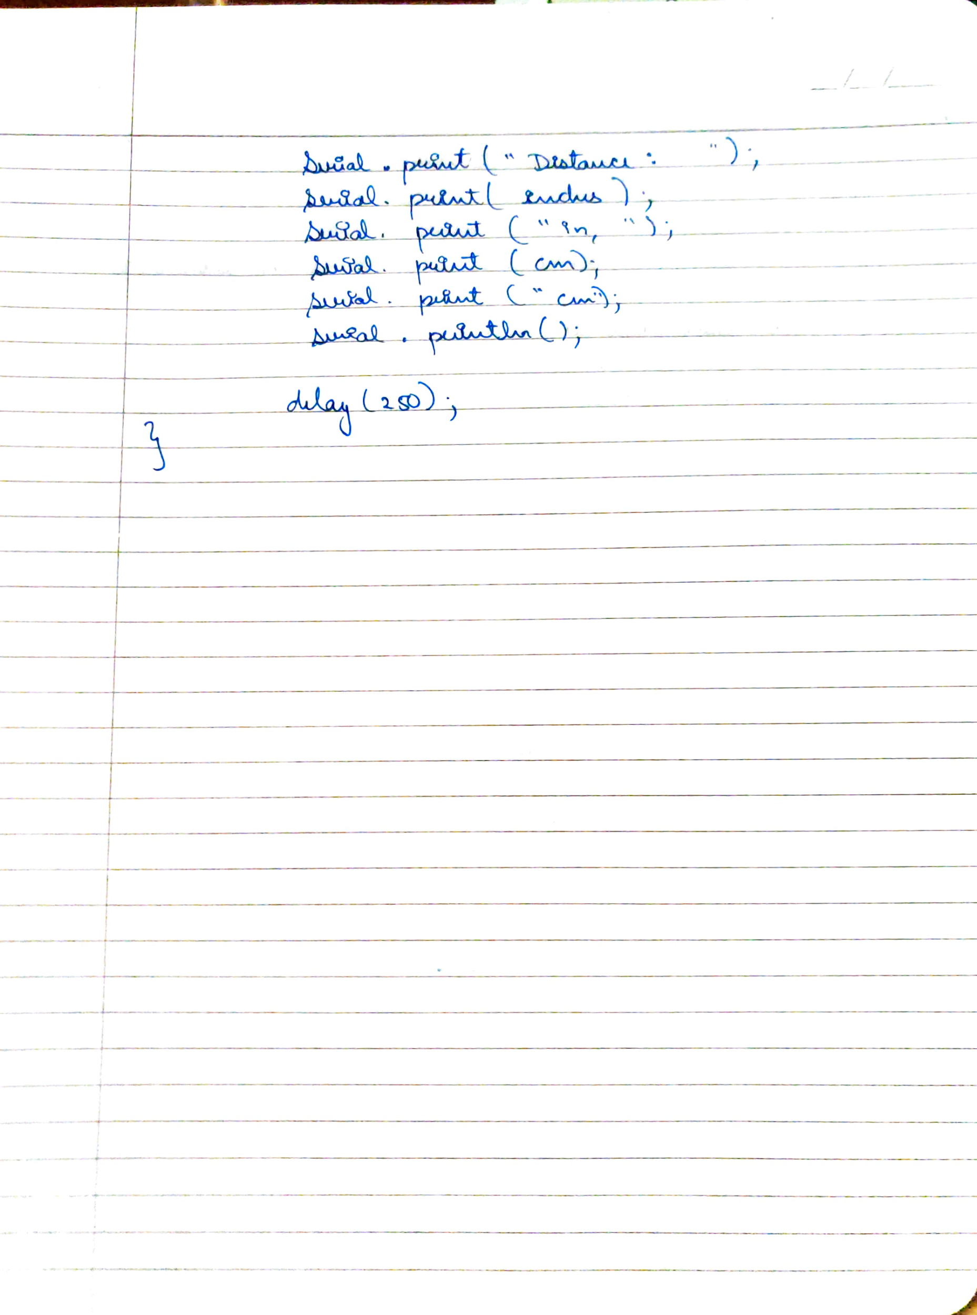

**CODE**

int trigPin = 4;

int echoPin = 2;

long duration, cm, inches;

void setup() {

Serial.begin (9600);

pinMode(trigPin, OUTPUT);

pinMode(echoPin, INPUT);

}

void loop()

{

digitalWrite(trigPin, LOW);

delayMicroseconds(5);

digitalWrite(trigPin, HIGH);

delayMicroseconds(10);

digitalWrite(trigPin, LOW);

duration = pulseIn(echoPin, HIGH);

cm = (duration/2) / 29.1;

inches = (duration/2) / 74;

Serial.print("Distance: ");

Serial.print(inches);

Serial.print("inch, ");

Serial.print(cm);

Serial.print("cm");

Serial.println();

delay(250);

}

**OUTPUT**

Design a system to measure the distance between objects using ultrasonic device.